MGT 40750 – Quantitative Decision Modeling Spring 2017

**End-of-Class Exercises: Roulette**

Name: _______________________________

Suppose the total amount you start with is $80 and you want to hit the target of $100.Implement the straight $10 bet strategy:

**Always bet $10 unless you run out of money; Stop betting as soon as you hit the target.**

**Specify the @Risk Model in Excel:**

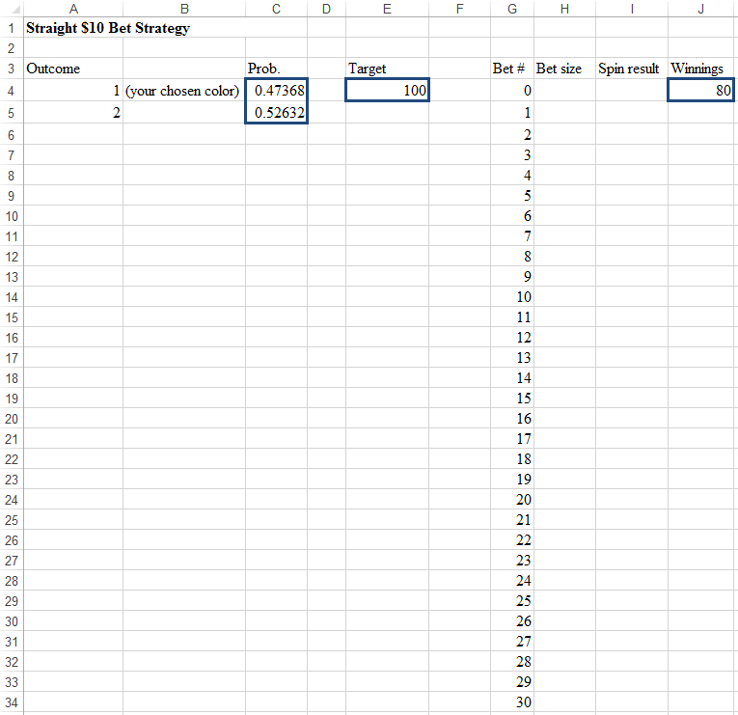

**What’s the probability of hitting the target after 30 bets?**